PROJECT: COMP 7081
WORK PACKAGE: Assignment 2 - Requirements Analysis Methods
ASSIGNED TO: students
EFFORT: 3 Person Days
DUE: Thursday, November 12, 2009, 10:30 PM

PURPOSE: Produce a requirements analysis of the system described in the attached problem statement.

INPUTS: · COMP 7081 Course Notes
· Text

ACTIVITIES: · Review Course Notes on requirements analysis.
· Prepare a use case model (including text descriptions for each use case and actor) for the requirements, which is consistent with the information below.
· Prepare corresponding view of participating class diagram for each use case, together with a corresponding use case realization (sequence or collaboration diagram).
· Integrate the VOPC diagrams to produce a class model, together with packages and (if appropriate) levels. Produce a state diagram for any classes which have significant state.

OUTPUTS: · Object-Oriented requirements model:
(1) use case model
(2) VOPC and use case realizations for each use case
(3) class diagram and state diagrams

SUBMISSION: Produce a MS word document with your work and submit it in the sharein on or before the due data/time.

This assignment can be done in teams of up to three students.
Problem Statement

This system consists of a number of bottle-filling lines fed by a single vat containing the liquid to be bottled. Figure 1 shows some details of the vat apparatus and of a representative bottling line.

Because of the single vat, the composition of the liquid being placed in the bottles is identical for all lines at a given time. However, the bottle size may differ from line to line. For example, one bottling line might be filling one-liter bottles and another line might be filling five-liter bottles at 7:30 a.m., but both lines would be using liquid maintained at a constant pH< say 6.52.

The tasks of the control system are to control the level and the pH of the liquid in the vat, to manage the movement and filling of bottles on the various lines, and to exchange information with human operators working the individual lines and with an area supervisor monitoring the entire system.

The vat level control is accomplished by monitoring the level with a sensor and adjusting a liquid input valve accordingly. The requirement for controlling pH arises because the liquid to be bottled reacts with its surroundings, causing the pH to “creep” over time. A constant pH is maintained by introducing, through a control valve, small quantities of a chemical that reverses the pH “creep.” The addition rate of the pH changing chemical depends both on the current pH in the vat (measured by a pH sensor) and on the rate of flow of liquid through the tank (measured by the liquid input valve control).

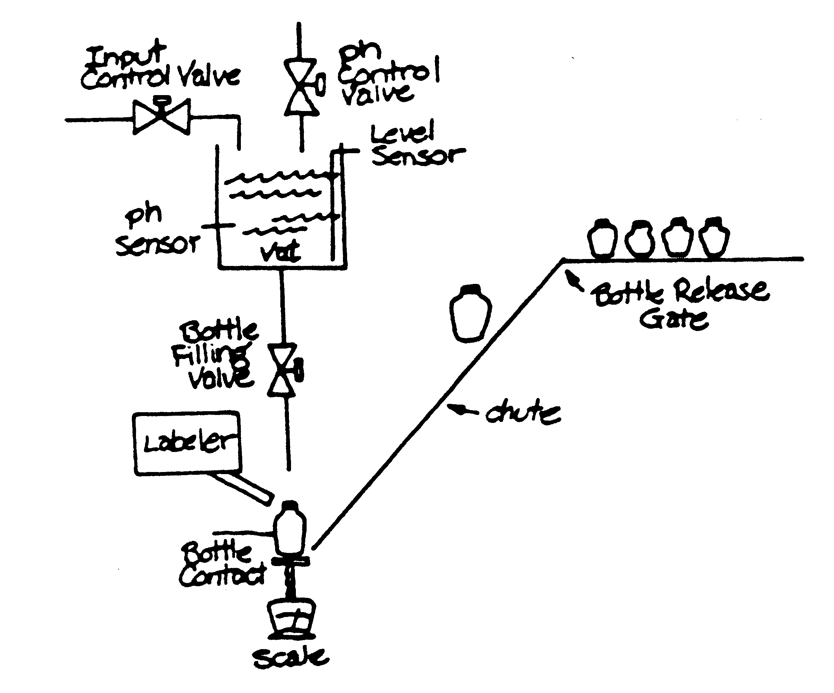

Figure 1 Bottle Filling Equipment Configuration

Bottles to be filled on a particular line are drawn one by one from a supply of bottles, as follows:
- A bottle is released from a gate and drops down a chute onto a scale platform, at the same time depressing a bottle contact sensor.
- The bottle-filling valve is opened, and a measured amount of liquid is let into the bottle. (The scale platform measures the weight of the bottle plus its contents, and is used to determine when the bottle is full and to shut off the valve).
- The filled bottle is labeled to show the actual pH when filled, and the nominal pH. The label operator caps and removes the filled bottle, and signals the system that the bottle has been removes. Removing the bottle releases the bottle contact sensor, removes the weight on the scale and allows the next bottle to be released from the gate.

The line operators can signal the system to start and stop individual lines, and the supervisor can signal the system to enable or disable overall operation of the set of lines. For a line to start operation from stopped status, both the area enable and line start signals are necessary; in addition, the bottle contact must be off and the scale platform reading must be less than 0.1 gram. The line operators are given displays of the line status (on/off and current bottle size) and are able to change bottle size for the line. The area supervisor is given a display of the current status of the system pH and vat levels and statuses of the individual lines, and is able to change the pH of the bottled liquid by entering a new pH to be maintained.

If, during operation of the system, the pH goes out of limits (>0.3 from the setpoint) all control actions are suspended. The vat pH is then stabilized manually. When the pH is back within limits, the system restarts automatically.
Figure 2 Context Diagram

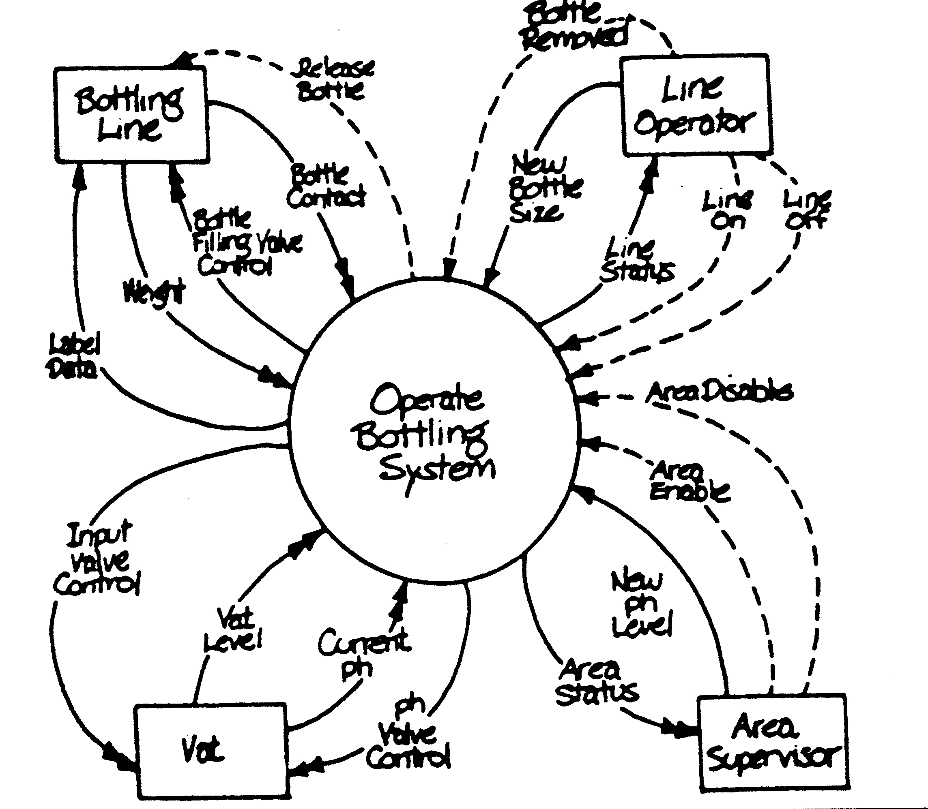
Event List (start of use cases)
- Supervisor enables area.
- Supervisor disables area.
- Supervisor sets new pH level.
- Operator turns line on.
- Operator turns line off
- Operator sets new bottle size.
- Operator removes bottle.
- Bottle drops into place.
- Bottle becomes full.
- pH moves out of limits.
- pH moves within limits

